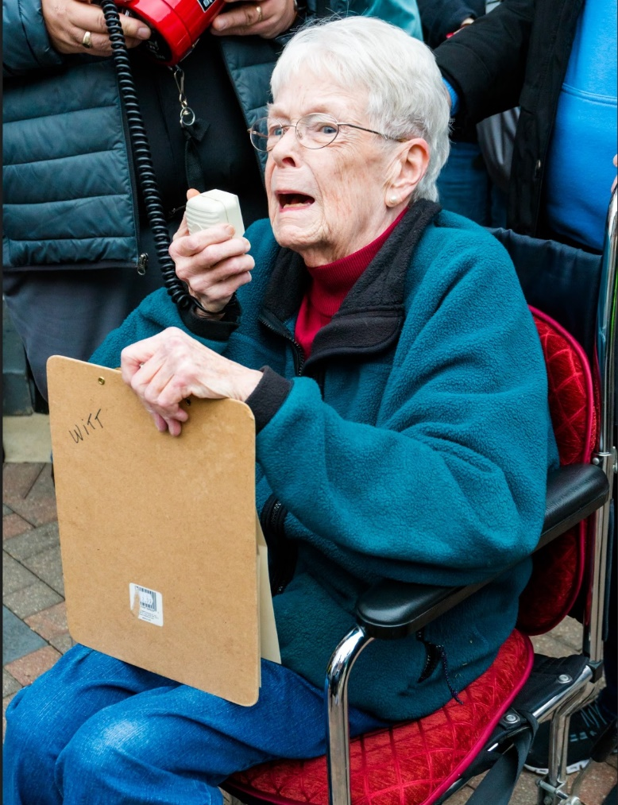

**Voting my values;  
Getting others out to vote**

Ella Elder  
Just Elder

932-202-2018  
ella@justelders.org

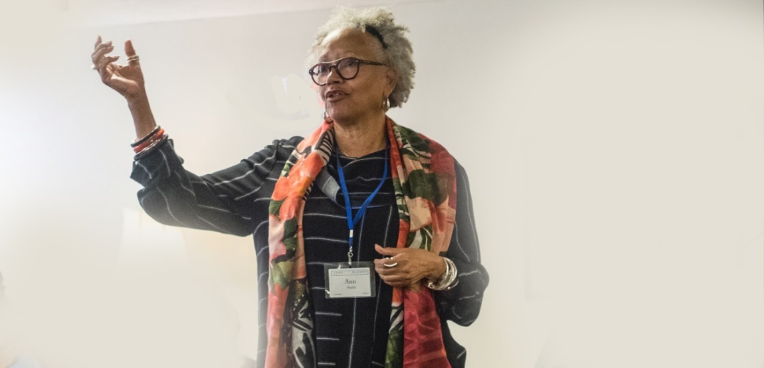

**Voting my values  
Getting others**

**out to vote**

Ella Elder  
Just Elder

**ella@justelders.org  
323-798-2018**

**Voting my values;  
Getting others out to vote**

Rev. Ella Elder  
Just Elder

343-765-2018 ella@justelders.org

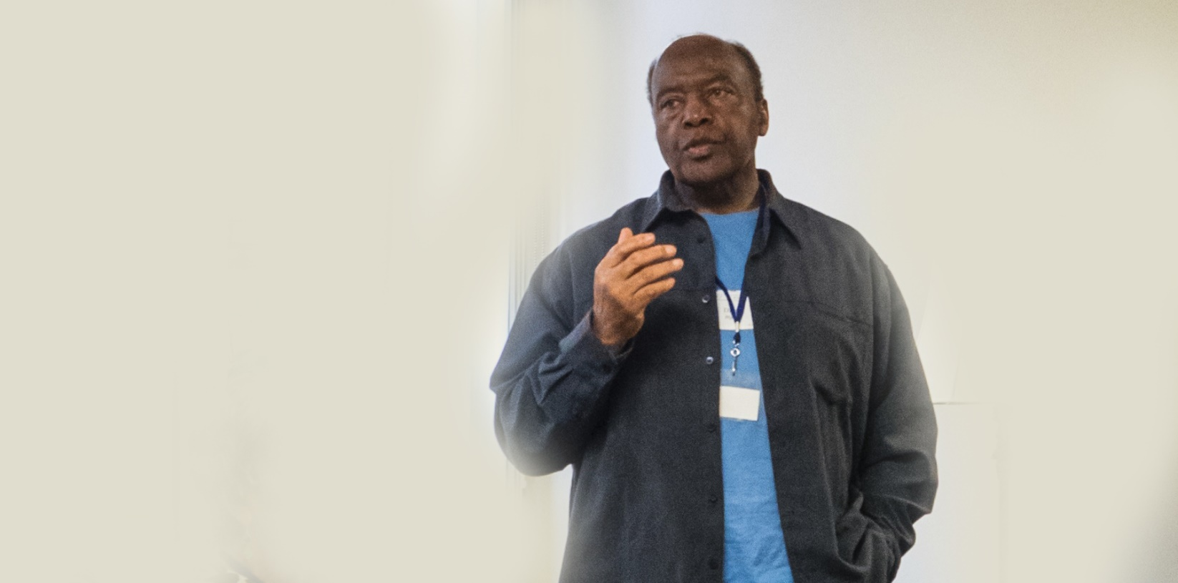

**Voting my values**

**Getting others out to vote**

Rev. Ervin Elder  
Just Elder

323-445-2019

ervin@justelders.org

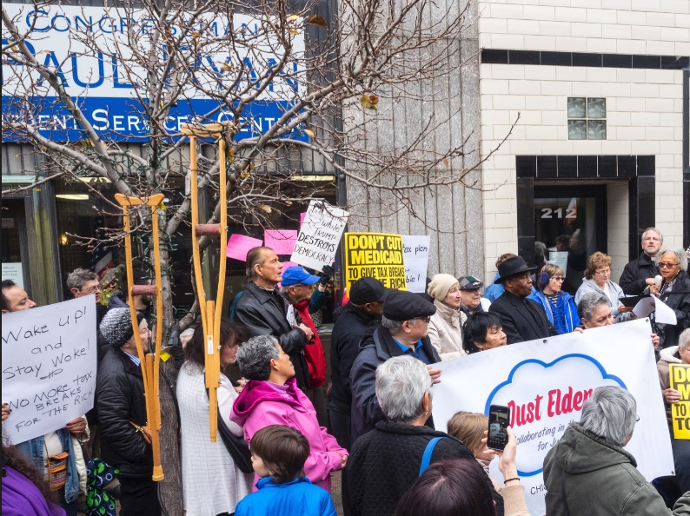

**Voting my values;**  
**Getting others out to vote**

**Ella Elder   
Just Elder**

**932-202-2018**

**ella@justelders.org**

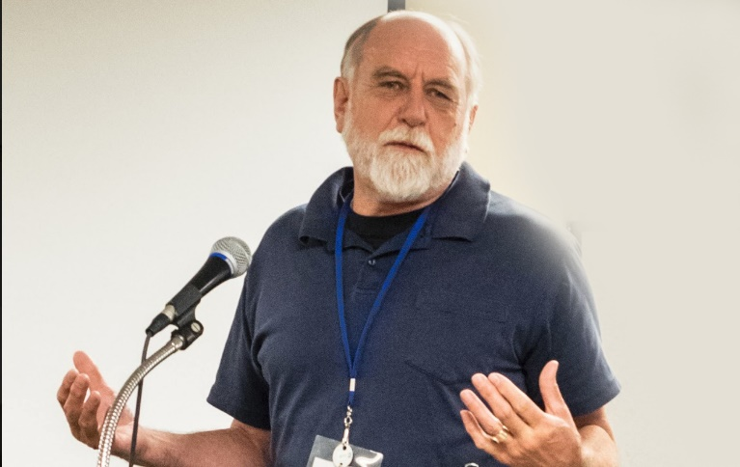

Voting my values;  
**Getting others**

**out to vote**

Rev. Evan Elder  
Just Elder

Evan@justelders.org  
323-898-2018

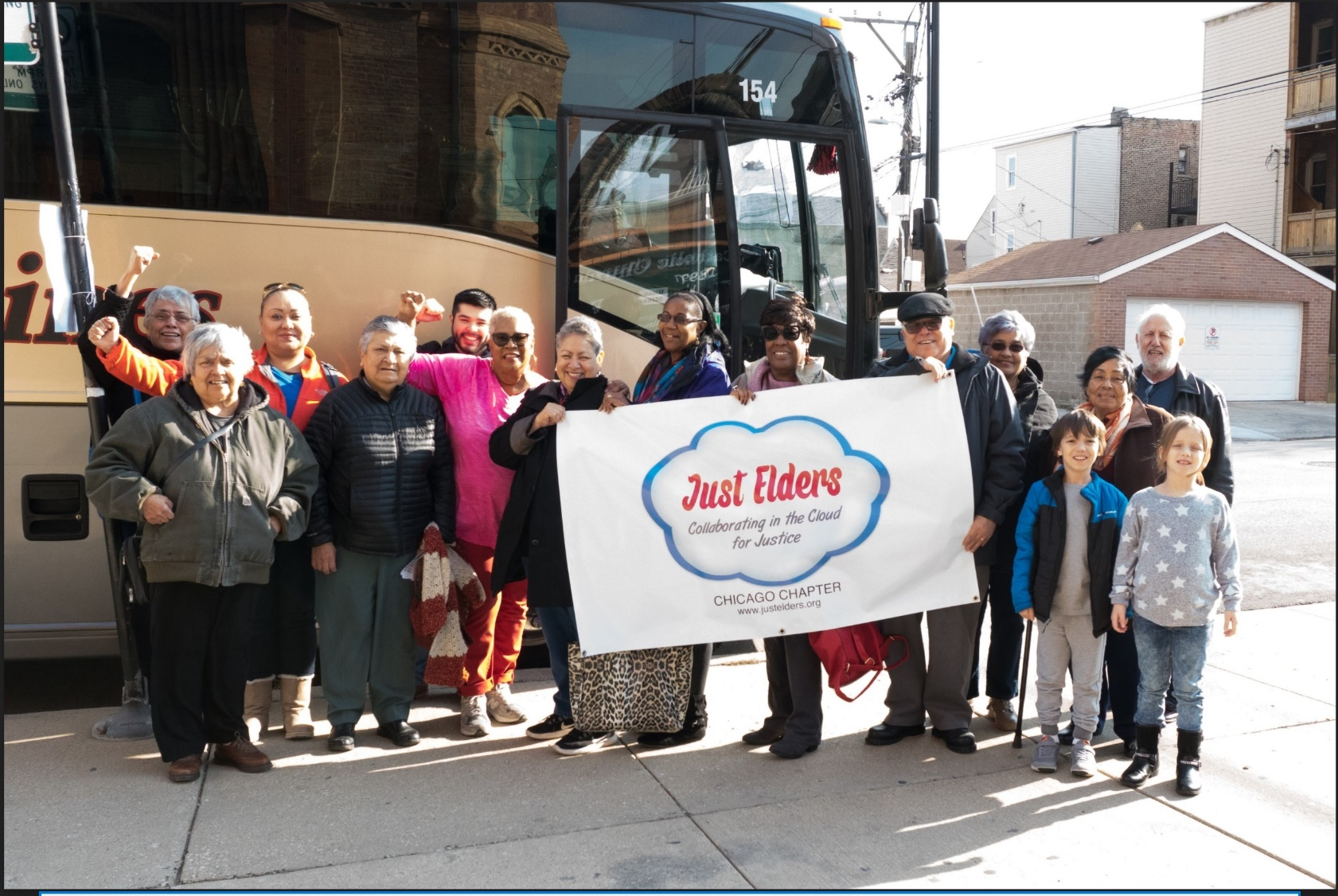

**Voting my values;  
Getting others out to vote**

Rev. Ella Elder  
Just Elder

Ella@justelders.org  
879-323-2018

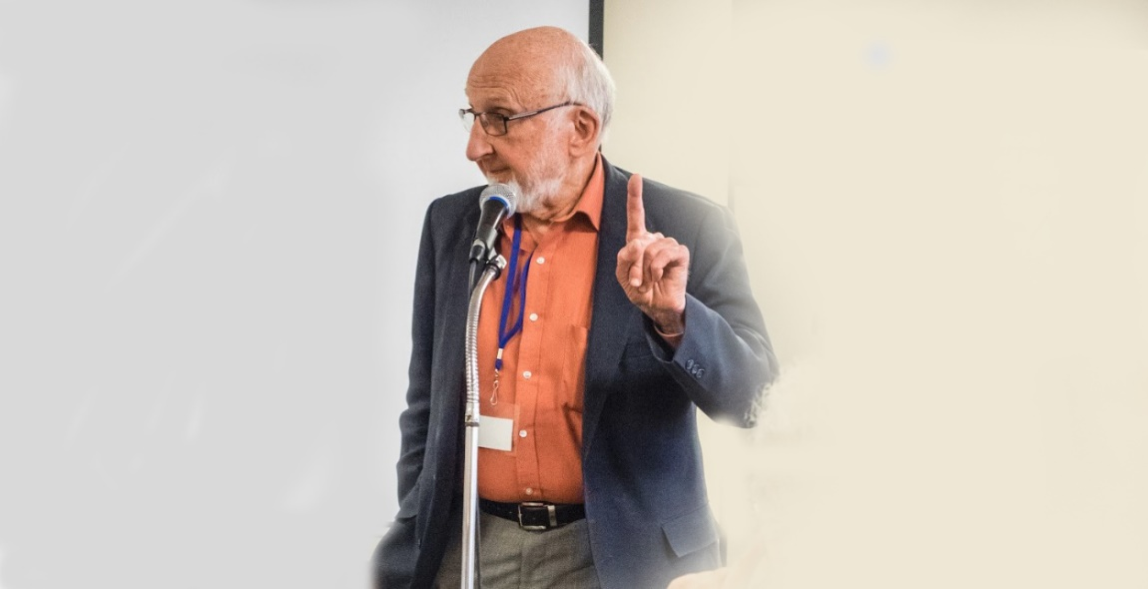

**Voting my values;  
Getting others out to vote**

Ervin Elder

Just Elder

323-455-2018  
ervin@justelders.org

**Voting my values**

**Getting others out to vote**

Rev. Ella Elder  
Just Elder

323-465-2018  
ella@justelders.org

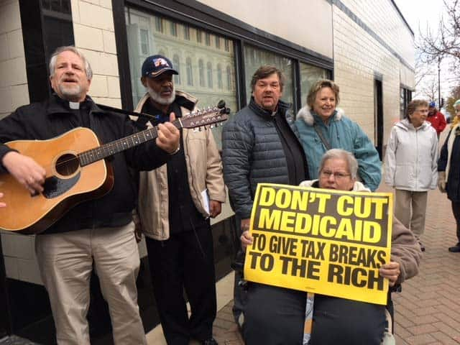

**Voting my values;  
Getting others out to vote**

Rev. Ervin Elder  
Just Elder  
  
  
**323-456-2018  
ervin@justelders.org**