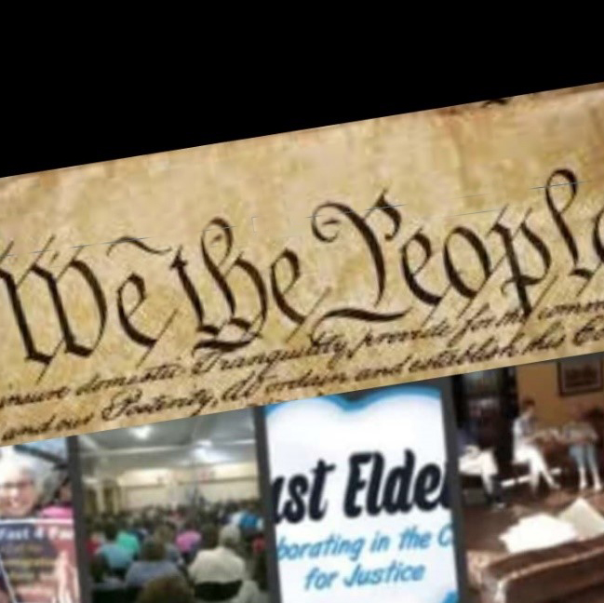

is a JUST ELDERS campaign demanding
GOVERNANCE NOT GRIDLOCK
from those elected to represent us
at the local, state and federal
levels of government.

This campaign is rooted in a decades’ old reality that the people who represent us fail to deliver the government we need and expect. The list of unresolved issues continues to grow year after year.
environment | incarceration
economy | immigration
education | voting
healthcare | racism
safety | inequality

NEEDED LEGISLATION IS TRAPPED IN POLITICAL GRIDLOCK.

OUR MESSAGE TO OUR REPRESENTATIVES US IS SIMPLE AND POSTIVE!

“WE WILL VOTE FOR THOSE WORKING ON LONG TERM BI-PARTISAN SOLUTIONS FOR THE ISSUES OF THE AMERICAN MAJORITY.”

JOIN US AT
WWW.JUSTELDERS.ORG/WETHEPEOPLE

Click “I’m in!” THEN LEAD WHERE EVER YOU ARE!

