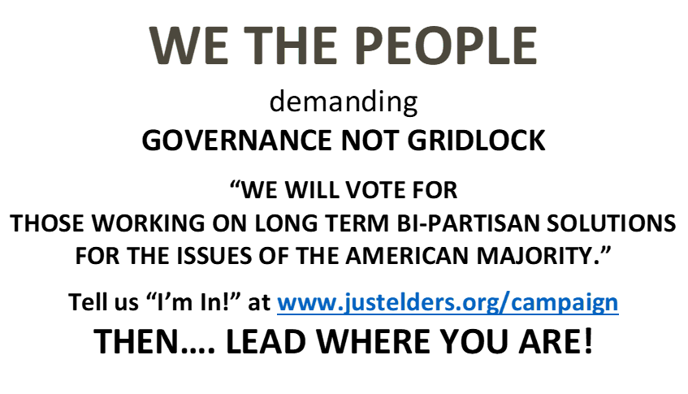

**WE THE PEOPLE**

demanding

**GOVERNANCE NOT GRIDLOCK**

**“WE WILL VOTE FOR   
THOSE WORKING ON LONG TERM BI-PARTISAN SOLUTIONS FOR THE ISSUES OF THE AMERICAN MAJORITY.”**

**Tell us “I’m In!” at** [**www.justelders.org/campaign**](http://www.justelders.org/campaign) **THEN…. LEAD WHERE YOU ARE!**

**WE THE PEOPLE**

demanding

**GOVERNANCE NOT GRIDLOCK**

**“WE WILL VOTE FOR   
THOSE WORKING ON LONG TERM BI-PARTISAN SOLUTIONS FOR THE ISSUES OF THE AMERICAN MAJORITY.”**

**Tell us “I’m In!” at** [**www.justelders.org/campaign**](http://www.justelders.org/campaign) **THEN…. LEAD WHERE YOU ARE!**