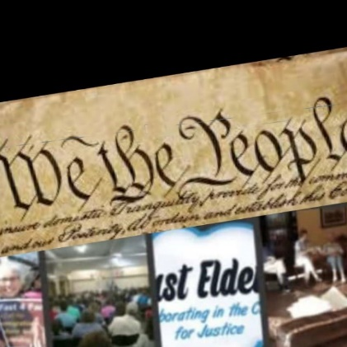

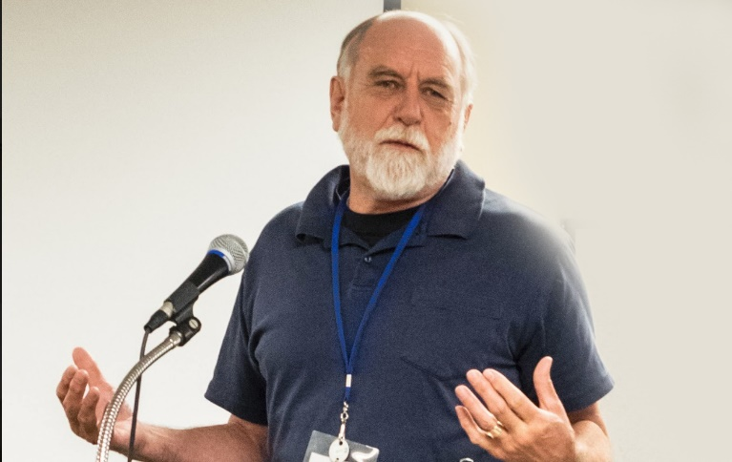

WE THE PEOPLE

**Ending Gridlock!**

Rev. Evan Elder  
Just Elder

Evan@justelders.org  
323-898-2018

WE THE PEOPLE

Ending Gridlock!

Ella Elder

222-222-2222

ella@justelders.org

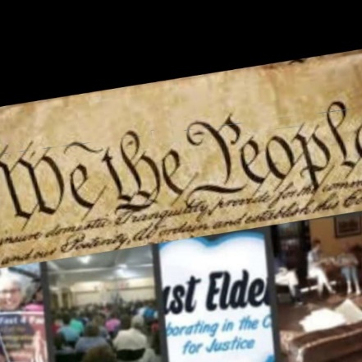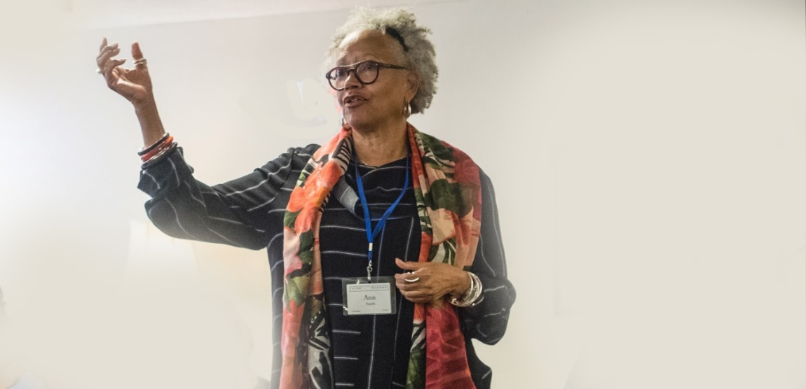

**WE THE PEOPLE  
Ending Gridlock**

Ella Elder  
Just Elder

**ella@justelders.org  
323-798-2018**

**WE THE PEOPLE  
Ending Gridlock!**

Rev. Ella Elder  
Just Elder

343-765-2018 ella@justelders.org

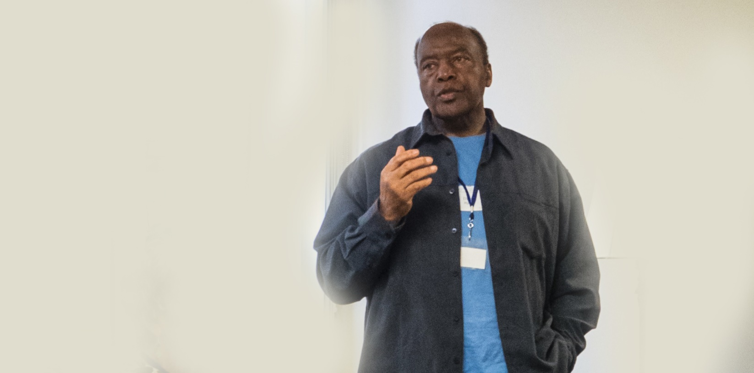

**WE THE PEOPLE**

**Ending Gridlock!**

Rev. Ervin Elder  
Just Elder

323-445-2019

ervin@justelders.org

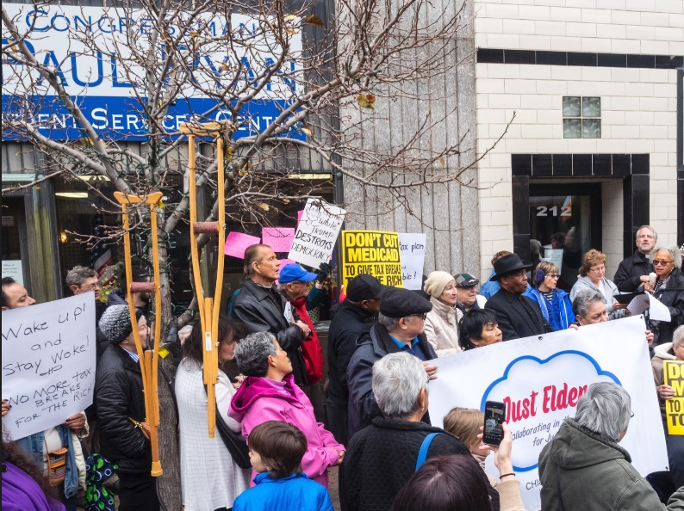

**WE THE PEOPLE**

**Ending Gridlock!**

**Ella Elder   
Just Elder**

**932-202-2018**

**ella@justelders.org**

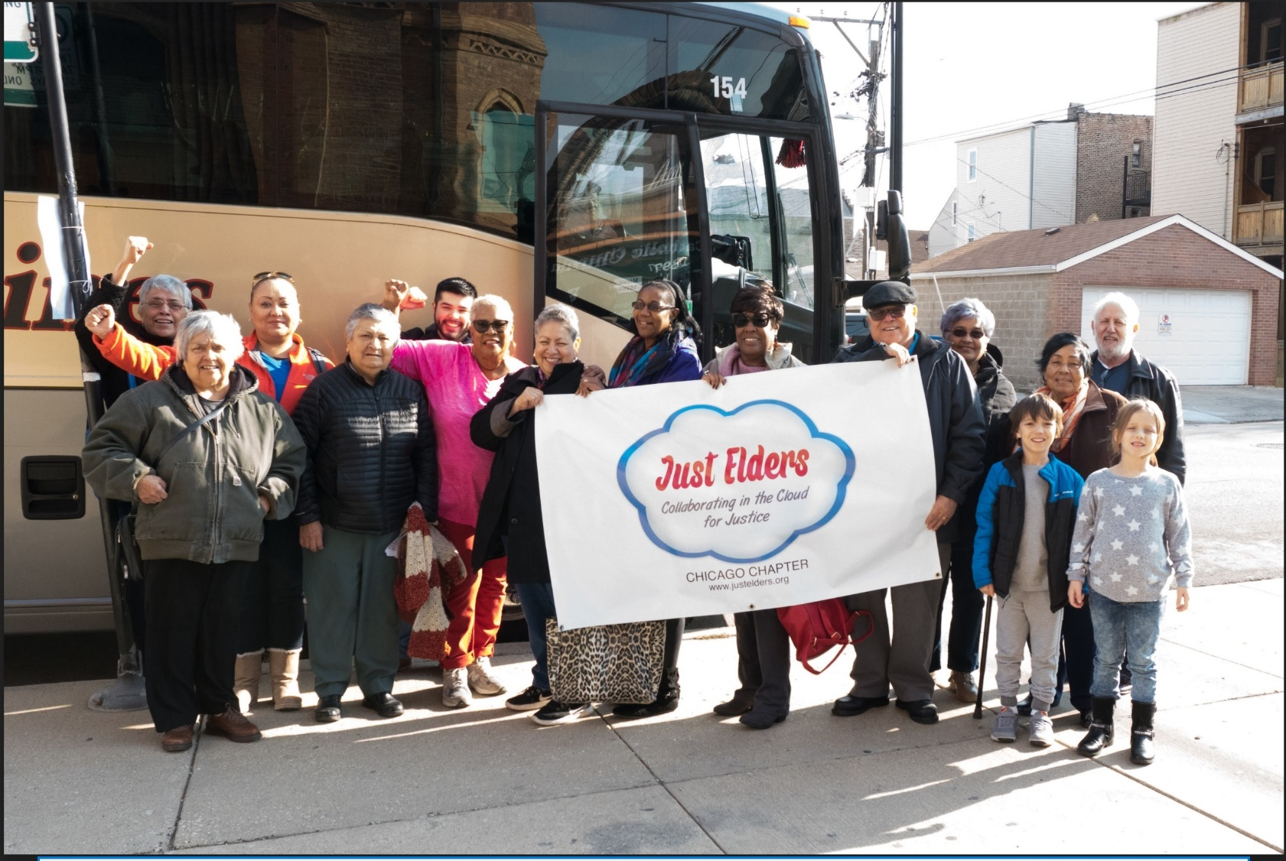

**WE THE PEOPLE  
Ending Gridlock!**

Rev. Ella Elder  
Just Elder

Ella@justelders.org  
879-323-2018

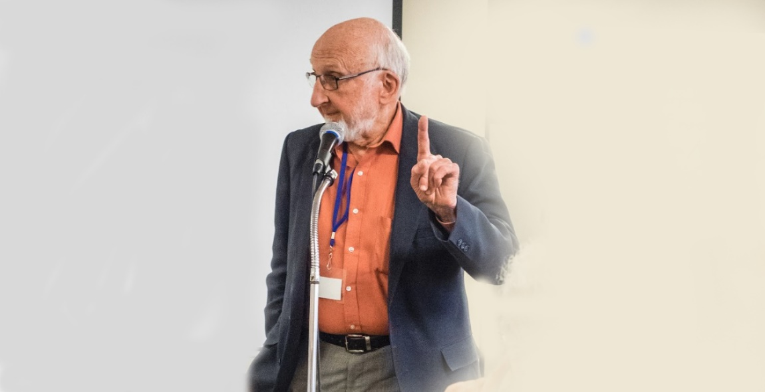

**WE THE PEOPLE  
Ending Gridlock!**

Ervin Elder

Just Elder

323-455-2018  
ervin@justelders.org

**WE THE PEOPLE**

**Ending Gridlock!**

Rev. Ella Elder  
Just Elder

323-465-2018  
ella@justelders.org

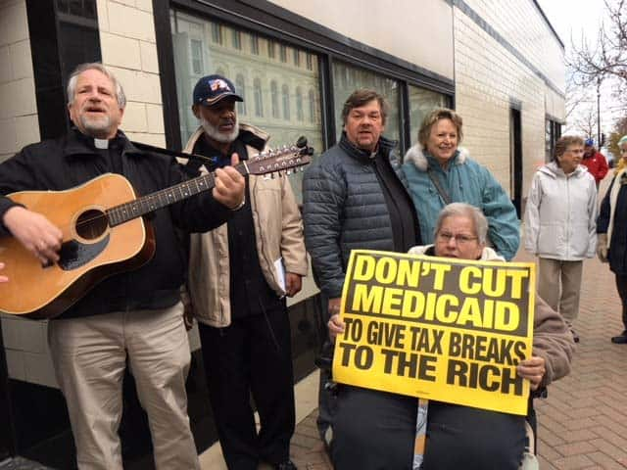

**WE THE PEOPLE  
Ending Gridlock**

Rev. Ervin Elder  
Just Elder  
  
  
**323-456-2018  
ervin@justelders.org**